Indonesian Foreign Minister Meets Timor-Leste Foreign Minister to Discuss Economic and Border Cooperation

Jakarta, 13 July 2023 - Indonesian Foreign Minister, Retno Marsudi, held a bilateral meeting with Timor-Leste Foreign Minister, Bendito Dos Santos Freitas, on the sidelines of the ASEAN Post-Ministerial Conference (PMC) in Jakarta (13/7). The two ministers discussed enhancing economic cooperation and border issues.

Both Foreign Ministers emphasised that the development of the Economic Zone along the Timor-Leste-East Nusa Tenggara border and the Oe-Cusse Ambeno region is a priority for both governments.

Regarding the border, the ministers agreed to resolve the long-standing land border issues in two segments. Discussions on maritime boundaries will be conducted after the land boundaries are settled.

The Timor-Leste Foreign Minister expressed appreciation for Indonesia's continuous support, including within ASEAN. Minister Bendito reaffirmed his commitment to collaborate with Indonesia in advancing the bilateral relationship.

***

For further information, please contact the following:

Director for Information and Media of the Ministry of Foreign Affairs - Hartyo Harkomoyo (+62811831899)

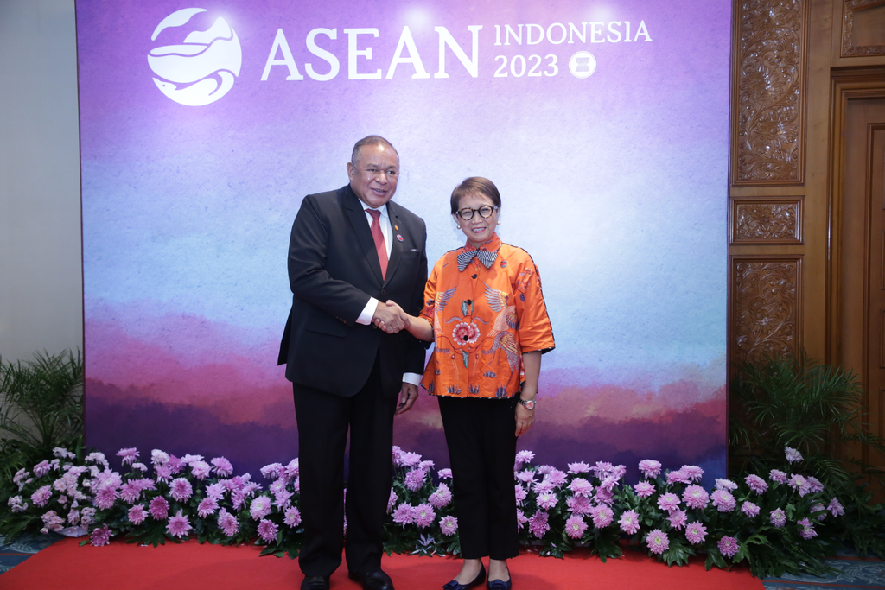

Indonesian Foreign Minister, Retno Marsudi, held a bilateral meeting with Timor-Leste Foreign Minister, Bendito Dos Santos Freitas, on the sidelines of the ASEAN Post-Ministerial Conference (PMC) and discussed enhancing economic cooperation and border issues (13/7) (Photo: Ministry of Foreign Affairs of Indonesia)

